DATA ANALYTICS

ASSIGNMENT-3

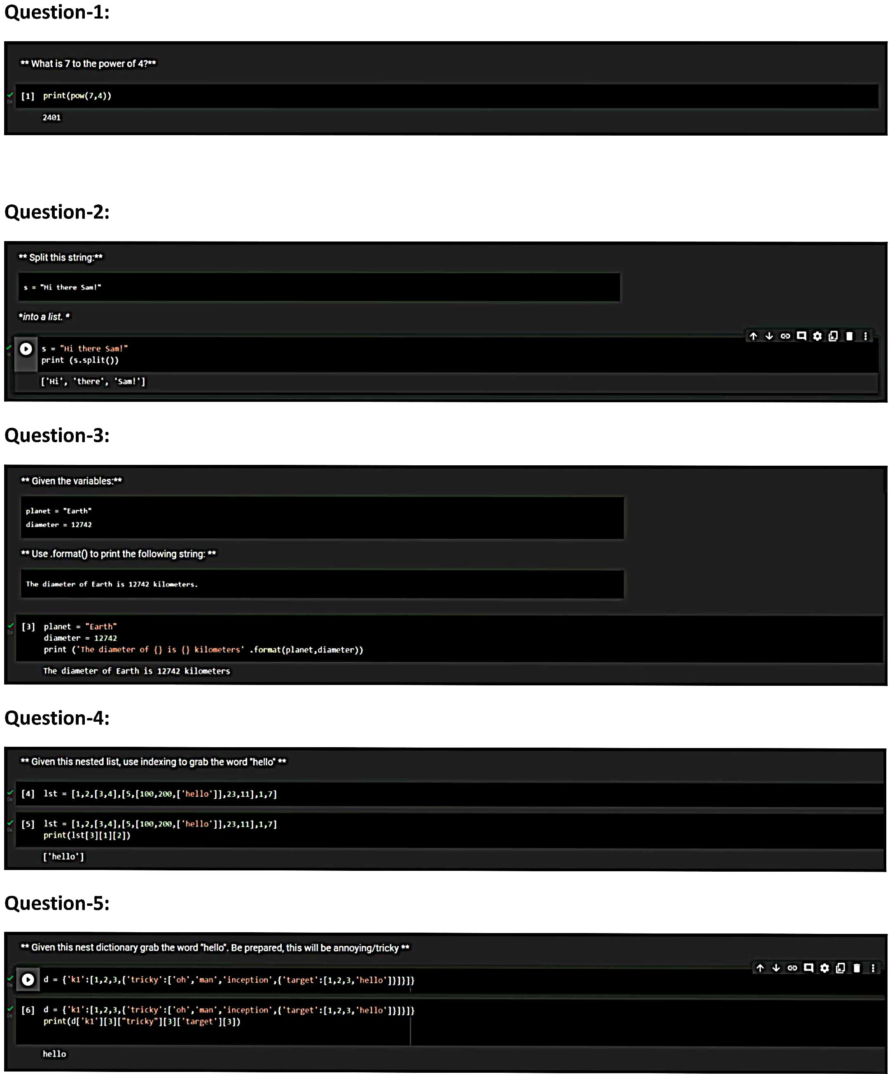

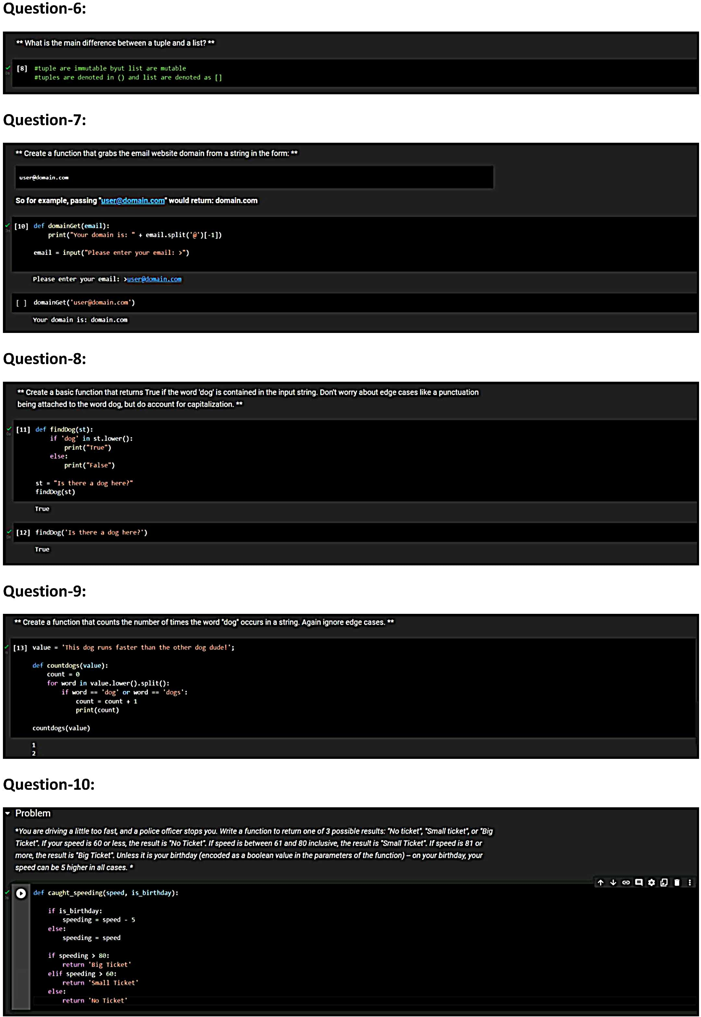

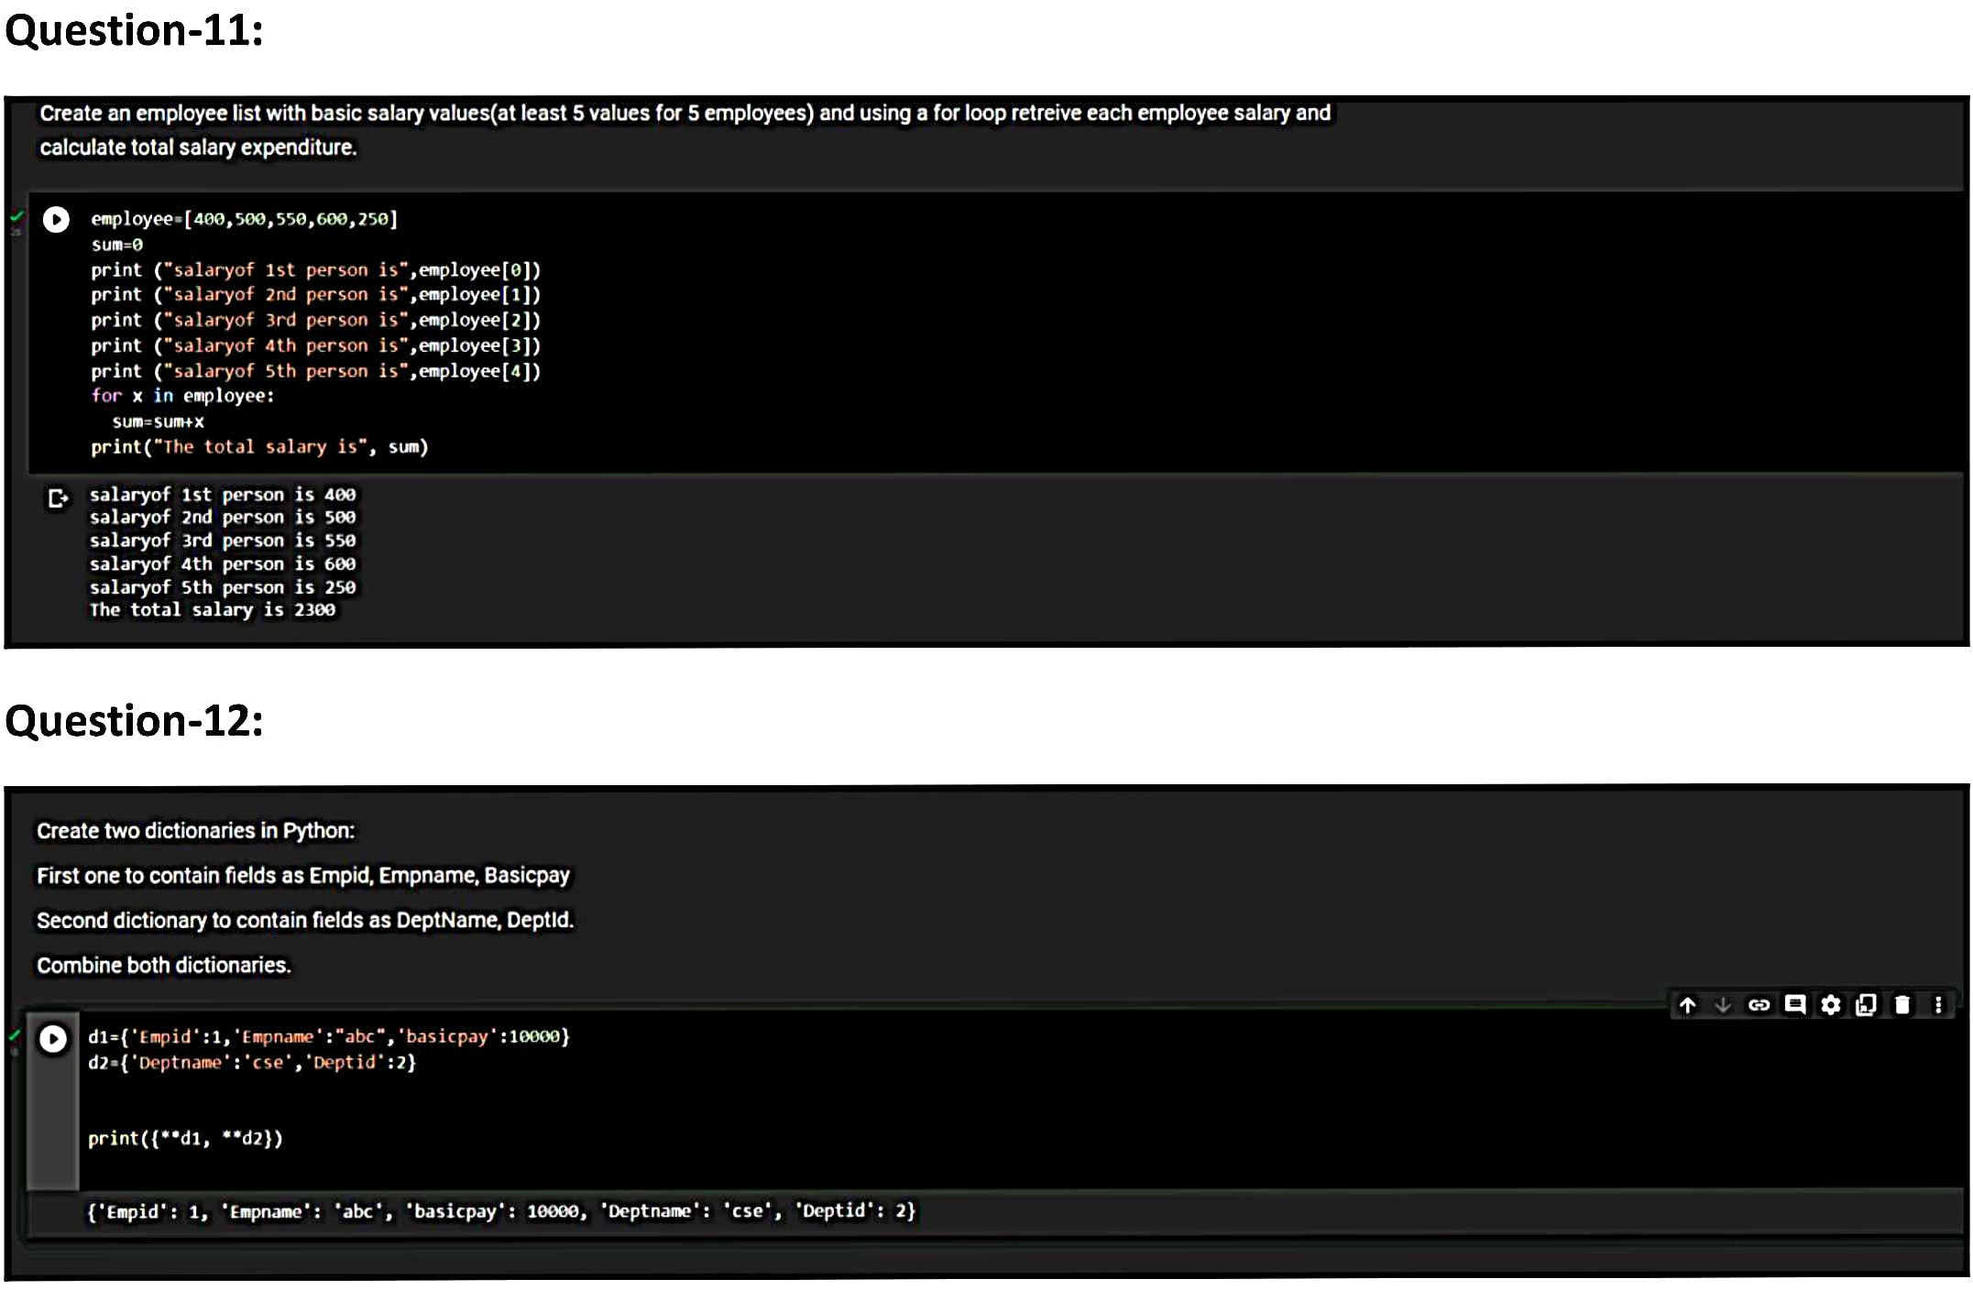

BY,

ABDUSH SAMAD M,

921319106002,

PSNACET.